1. Write a shell script which will generate the O/P as follows

*

**

***

****

1. Accept the first name, middle name, and last name of a person in variables fname, mname and lname respectively. Greet the person (take his full name) using appropriate message.

1. Display the name of files in the current directory along with the names of files with maximum & minimum size. The file size is considered in bytes.

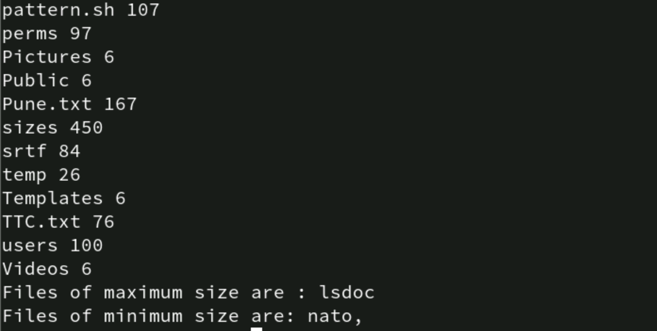

1. Write a script which when executed checks out whether it is a working day or not?

(Note: Working day Mon-Fri)



1. Write a script that accepts a member into HP health club, if the weight of the person is withing the range of 30-250 Kgs.

1. Write a shell script that greets the user with an appropriate message depending on the system time.

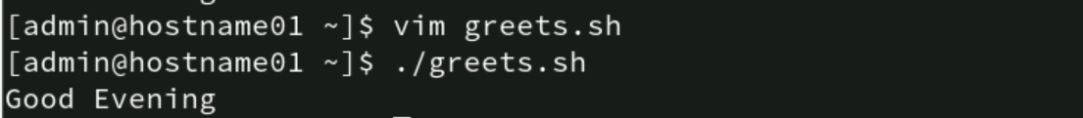

1. A data file file has some student records including rollno, names and subject marks. The fields are separated by a “:”. Write a shell script that accepts roll number from the user, searches it in the file and if the roll number is present - allows the user to modify name and marks in 3 subjects.   
   If the roll number is not present, display a message “Roll No Not Found”. Allow the user to modify one record at a time.

1. Modify program 7 to accept the RollNo from the command line.

1. Modify the program 7 to accept the RollNo and display the record and ask for delete confirmation. Once confirmed delete the record and update the data file.

1. Write a script that takes a command line argument and reports on its file type (regular file, directory file, etc.). For more than one argument generate error message.



1. Add some student records in the “student” file manually. The fields to be considered are “RollNo”, “Name”, “Marks_Hindi”, “Marks_Maths”, “Marks_Physics”.  
    Write a script which does the following
   1. If the roll number already exists, then store the record and the following message   
      “roll number exists” in a log file “log1”.

* 1. If the marks in the subjects is not in the range of 1 – 99 then store such a record followed by a message “marks out of range” in “log1”

* 1. If the data is valid, the calculate total, percentage, grade and display on the terminal

